34.85: Entering the sphere: 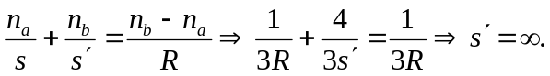
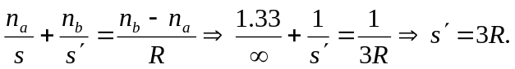
So the final image is a distance 3R from the right-hand side of the sphere, or 4R to the right of the center of the globe.

